1. Submission file: The files are in the folder (website.jsp + process.jsp).
2. Github Repo:

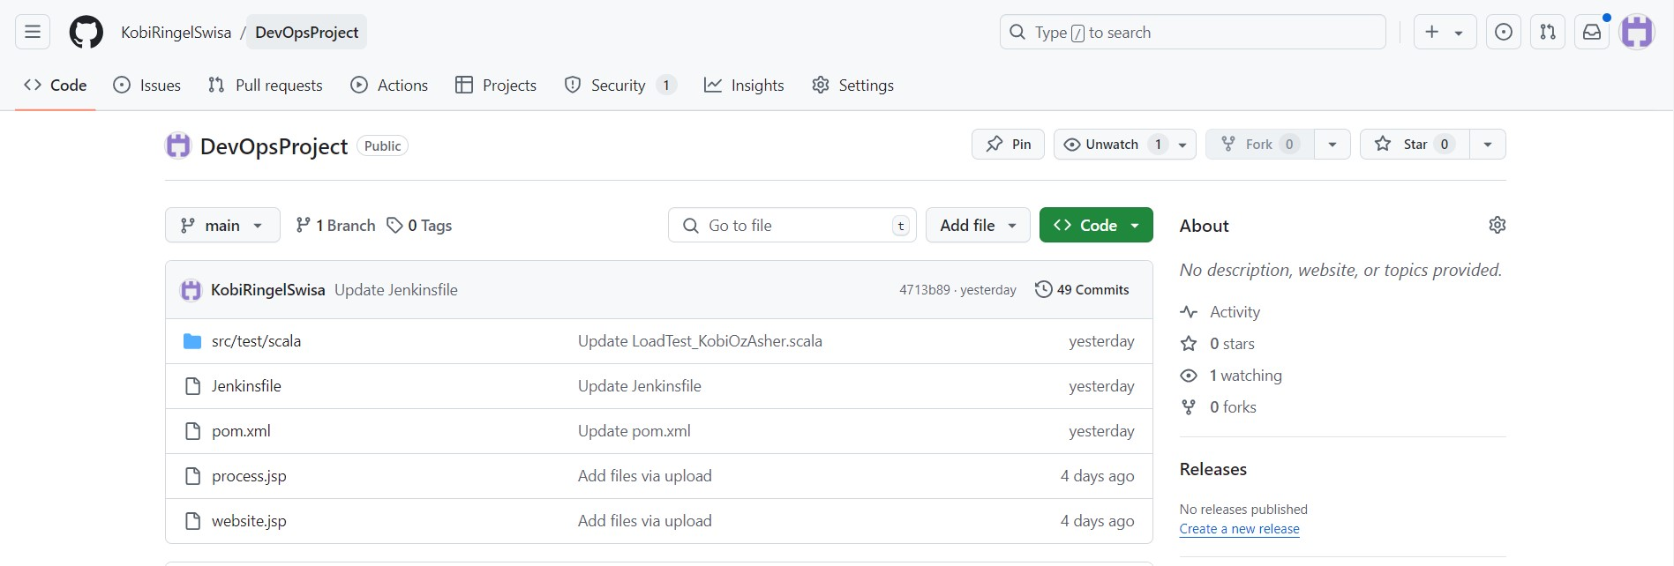

1. Tomcat connection (Port 8000):

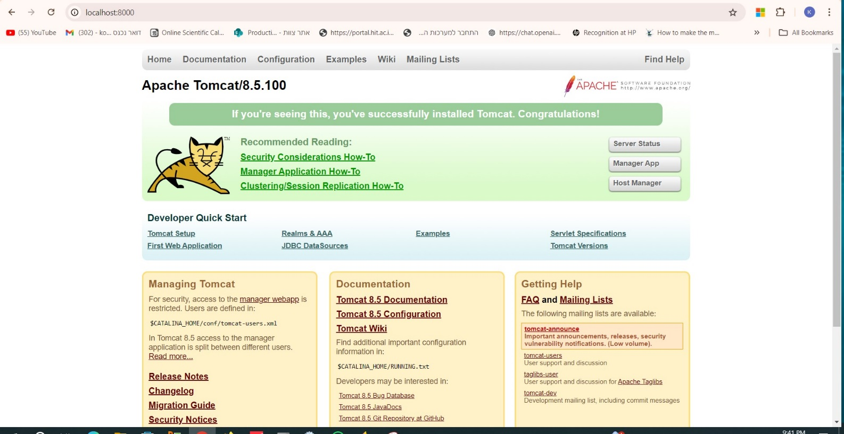

1. Monitor tool name: Uptime Robot, monitored our website (hosted with ngrok).  
   screenshots from Uptime Robot and Jenkins triggering the Job for each minute.

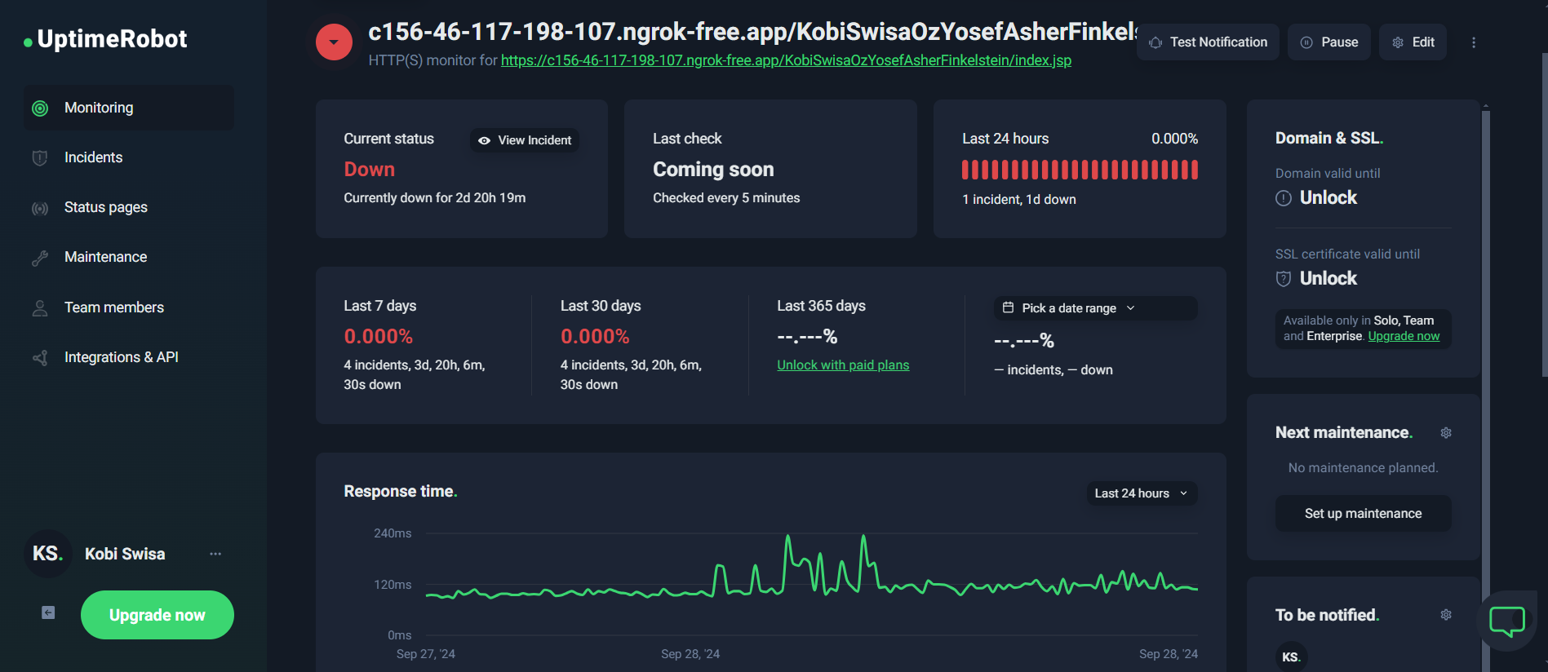

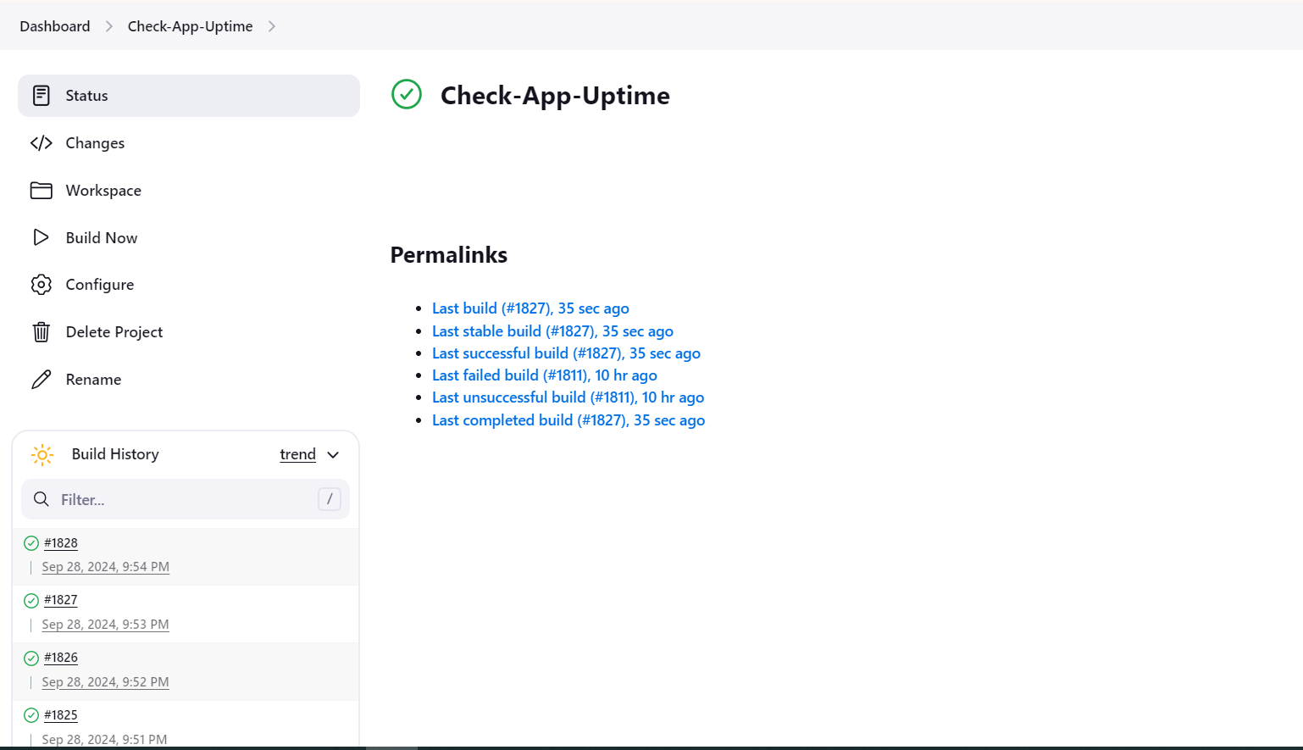

1. I used .java file for the selenium output (attached in the folder).
2. We don’t have the IDE (did not take the screenshot and the project was exported to .java file) but I have the screenshot from Jenkins that for the selenium test:  
   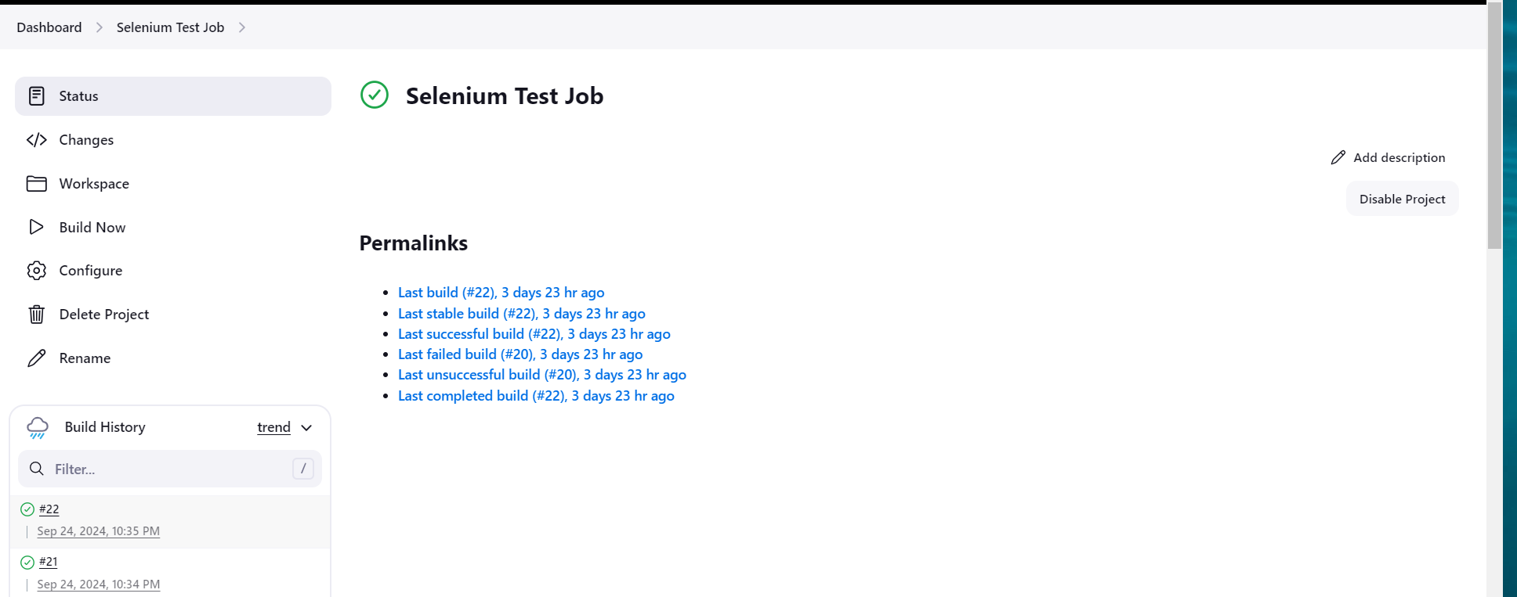
3. Click on the title and verify the title text -> click on the input line and insert some text -> click submit -> verify that the new page opened (verify the title of the new page) -> end of test.

i) Load test screenshots:  
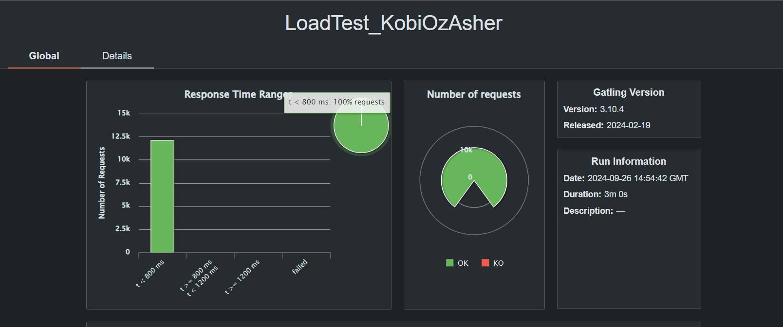

Stress test screenshots:

j) **Loading test** – The results looks as expected – during 4 minutes, there are +-100 concurrent users connected to the web site, the response time is good (around 200-400 ms).  
**Strees Test –** The overall results are not as we expected to be, the numbers show a high rated of KO , and the OK is on around 480 concurrent users. From our checkings, the host server was limiting the number of connections and although we changed the configurations in tomcat, the limit did not change. The second image of the graph shows a very good results with above 1K users and spikes that demonstrate a typical stress test.